**Heuristic Review of the “MedCheck” Web Application**

**Summary**

The 18F Hackathon UX team was tasked to perform an evaluation of the “MedCheck” website on 25 June 2015. This report summarizes the high level findings of this evaluation.

Two primary concerns were exposed. User comprehension of the data was made difficult by unclear site language and a lack of instruction. Unrefined data caused search findings to be inconsistent and unclear.

**Assessment Method**

Heuristic evaluation is an assessment method, which rates software applications, and interfaces based on compliance with basic human factors principles of design. For this evaluation, four areas were considered.

1. Perceiving and Evaluating the System
2. Developing and Executing Action Sequences
3. Context and Relations
4. Specific Interface and System Issues

**Overall Impressions**

From the MedCheck homepage, users can search for a medication to view associated recalls and adverse events. However no information on what data will be retrieved is available. There is no example data available and no description of the pages purpose. The page focus should be set on the input box on page load. Example data should be present in the search field to guide the user to the proper search type.

The MedCheck details page shows the medication and, if applicable, the generic name of the medication that was searched for. A description of the medication is shown as well as the associated total number of recalls and adverse events. The medication description data is inconsistent and can be unavailable or inaccurate. Five recalls are shown with the option to paginate through all returned recalls. If no recalls are available the pagination user interface should not be present and a message stating, “No recalls have been found for this search.” should be visible. The option to view recall details is not apparent and should be highlighted with the use of an icon or mouse over effect. Descriptions of the detail information should be available as mouse over tooltips on data labels.

The user has the option to view the adverse events and their details by selecting the adverse events tab. Five adverse events are shown with the option to paginate through all returned adverse events. If no adverse events are available the pagination user interface should not be present and a message stating, “No adverse events have been found for this search.” should be visible. The option to view adverse events details is not apparent and should be highlighted with the use of an icon or mouse over effect. Descriptions of the detail information should be available as mouse over tooltips on data labels.

**MedCheck Home Screen (Wireframe):**

* Logo centered at top (alt text for logo image)
* Search centered under logo (alt text for search button if image used)
* Search includes example input “i.e. Medication Brand Name”
* Focus is on search on page load
* App description and disclaimer needed

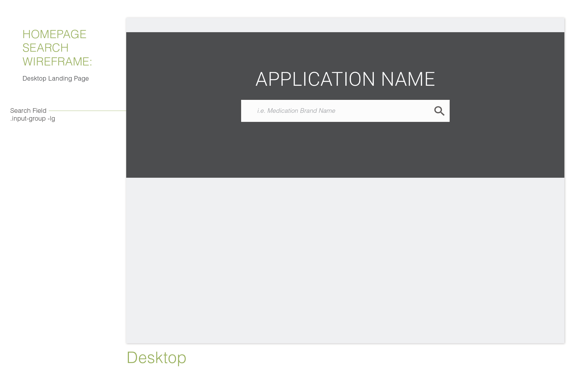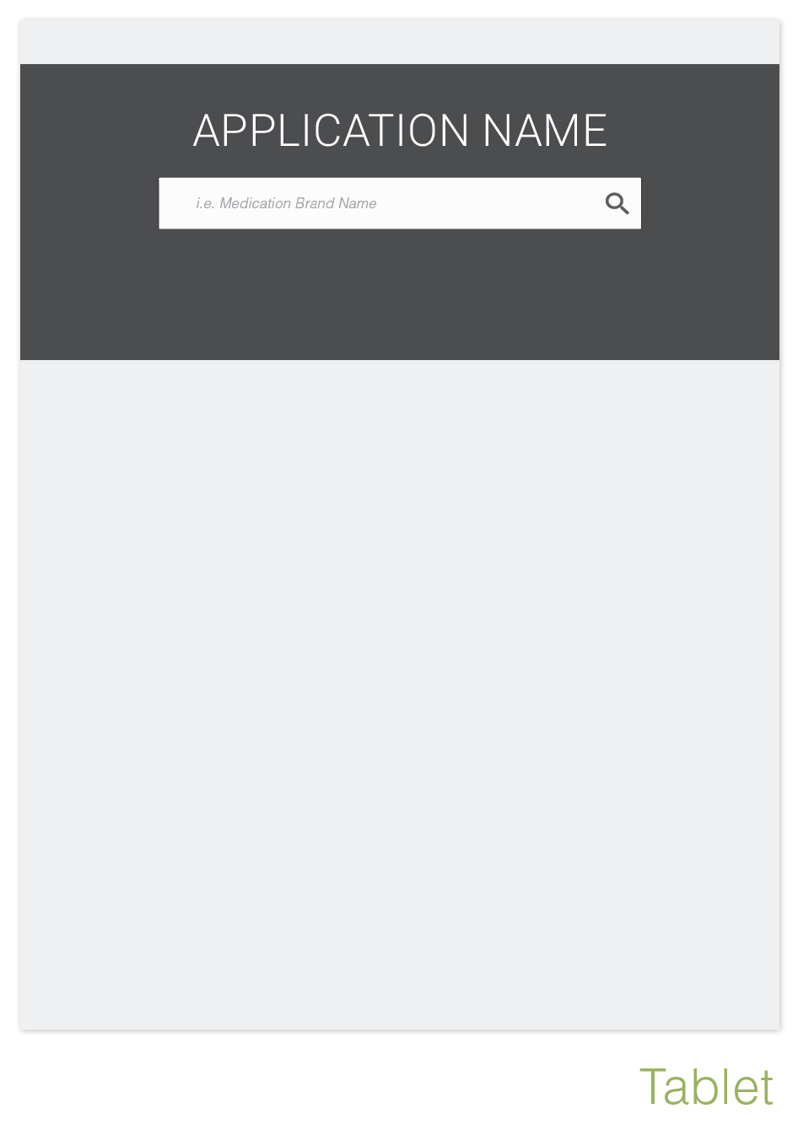

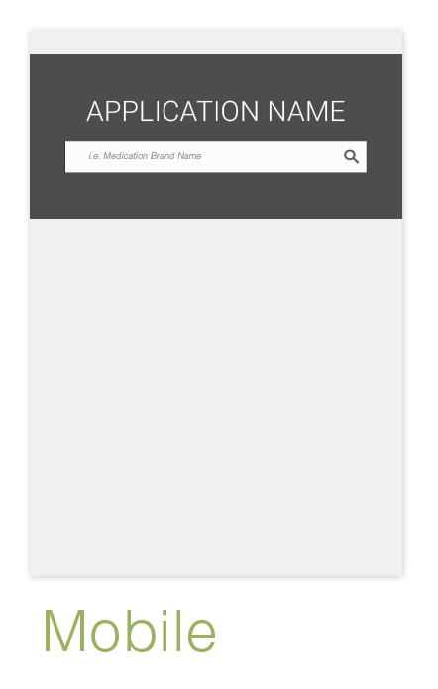

**MedCheck Details Screen (Wireframe):**

* Logo aligned left at top (alt text for logo image; link back to home page)
* Search aligned right (alt text for search button if image used)
* Search includes example input “i.e. Medication Brand Name”
* Focus is on search on page load
* Navigation unclear
* Expanding recall detailed information is not apparent
* Ability to view adverse events is not apparent

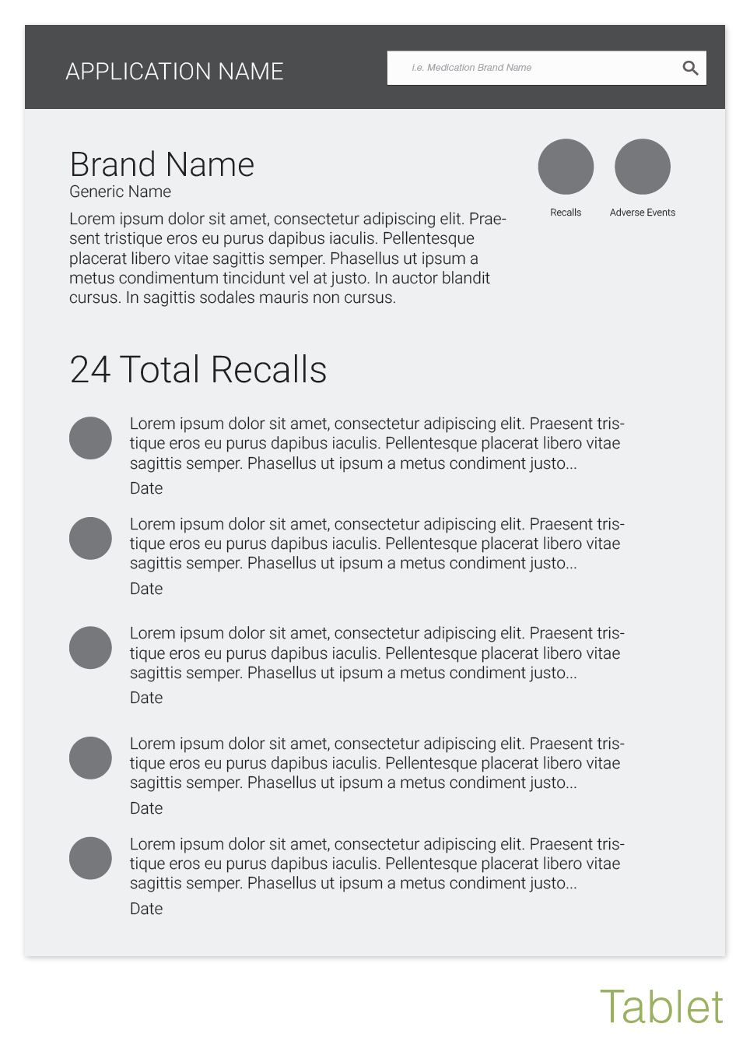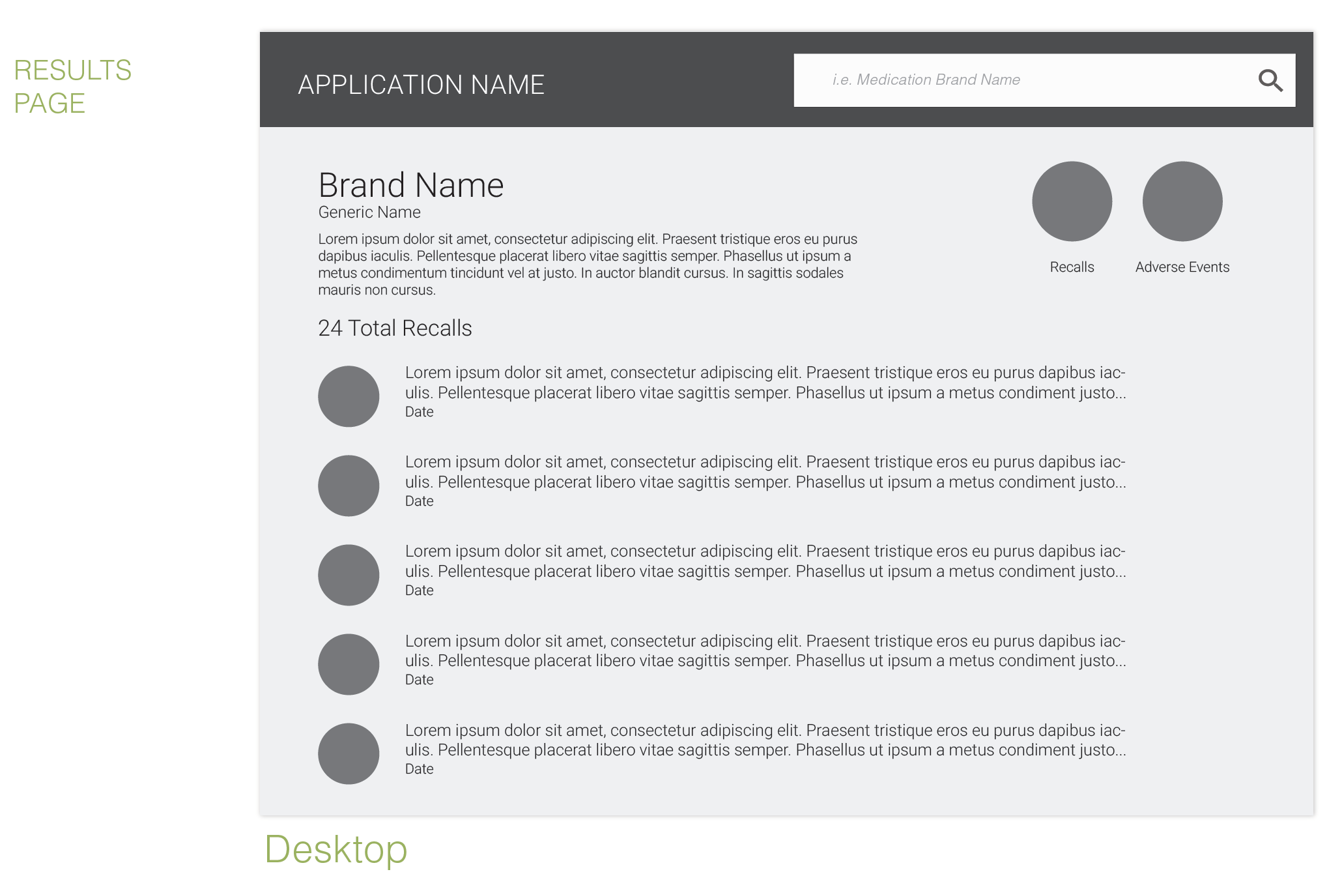

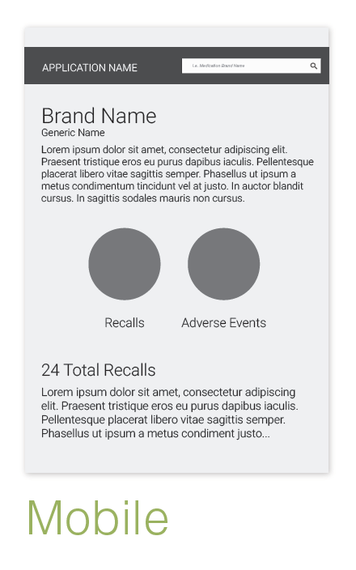**Conclusion**

A simple and informative search is necessary for an effective user experience. Clear direction and understandable terminology is needed. Accessibility should always be considered to allow for a diverse base of users.

Data should be presented in a way that is obvious to the user. All data points should relate to the medication searched and additional data should be understandable and accessible.

**Modifications Made**

* Intro text and disclaimer was added to home page.
* Example search text was added to search bar.
* Details page was redesigned to show adverse events first and created a link for recalls to a new left column along with medication data.
* Headers were given mouse over effects to show ability to interact and guide users to view details.
* Language was added for no results found.

**MedCheck Home Screen (2nd Release):**

1. Search Text
   * Search should not be Cap sensitive and results should include no duplications.
   * Language explaining site and disclaimer are needed.
2. Search Icon/Button
   * Alt text is needed for accessibility



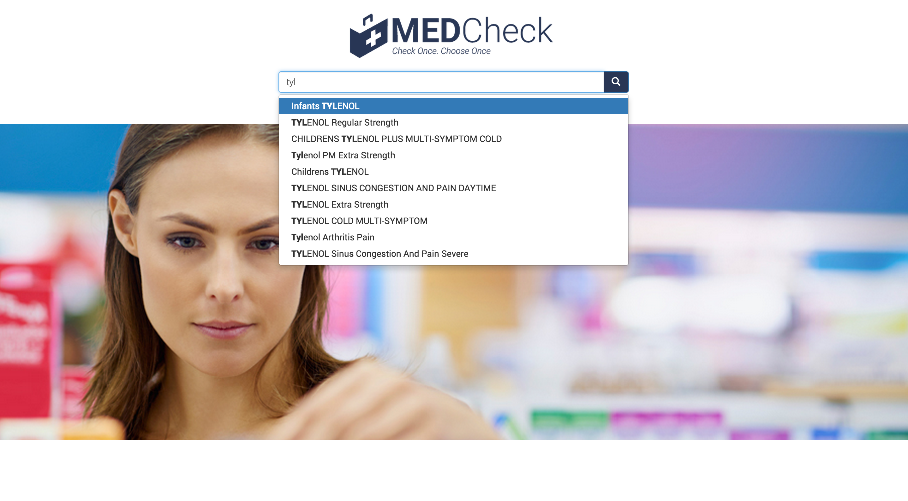

**MedCheck Details Screen (2nd Release):**

1. Screen Layout

* No results should show custom message and remove pagination
* Adverse events tab is inaccessible and not apparent
* Text wrapping with long numbers. (Number should show under header)

1. Data List
   * Item icon meaning is unclear (Tooltip on mouse-over)
   * Item header interaction is unclear (“+” icon or mouse-over effect)
   * ID number is should be removed from item header

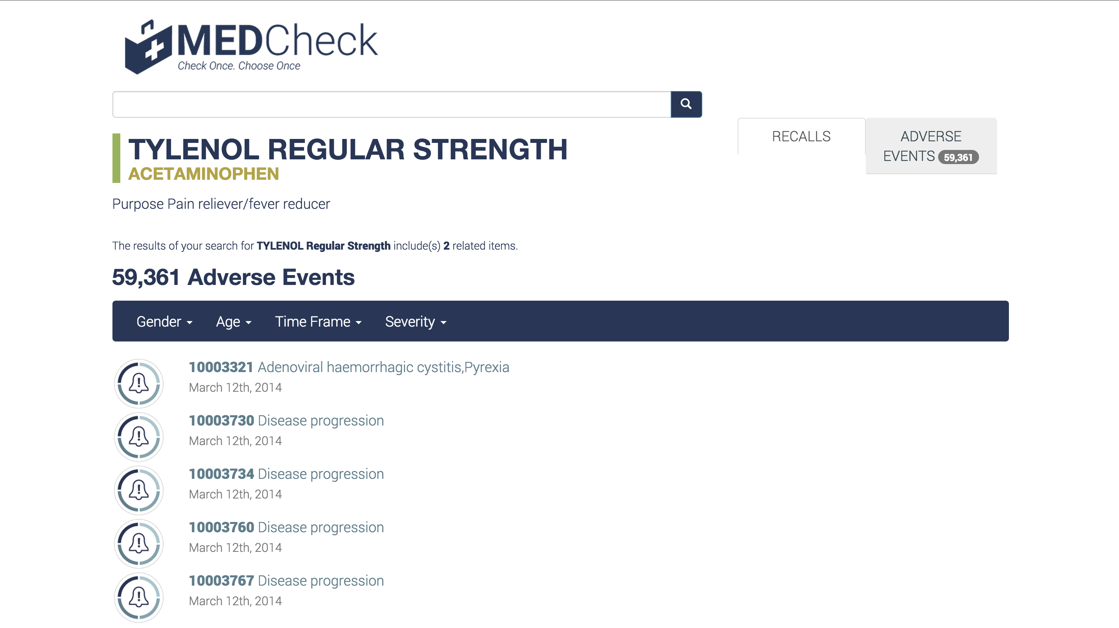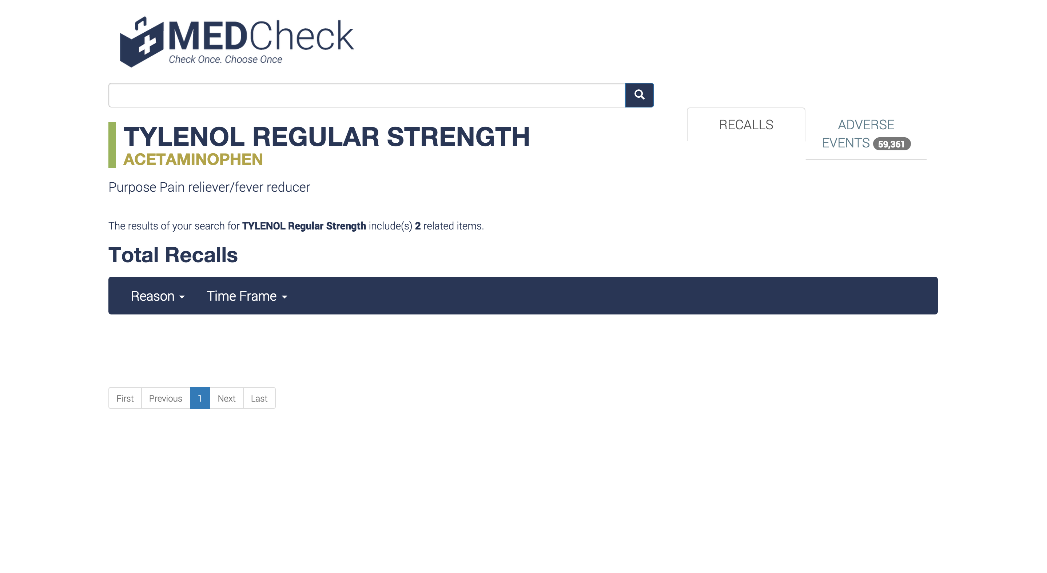

**Conclusion**

Searching for medications is the main user interaction and should be as simplistic as possible. Autocomplete as well as mistype leniency should be implemented to prevent errors. The user should also have access to a simple details screen that displays data in a way that is obvious to the user

The details page should show easily identifiable recalls and adverse events and understandable data points. The ability to view more details should be apparent